Identifying Primary and Secondary Resources

Sources of information are often categorized as primary or secondary depending upon their originality.

Primary Sources
A primary source provides direct or firsthand evidence about an event, object, person, or work of art. Primary sources provide the original materials on which other research is based and enable students and other researchers to get as close as possible to what actually happened during a particular event or time period. Published materials can be viewed as primary resources if they come from the time period that is being discussed, and were written or produced by someone with firsthand experience of the event. Often primary sources reflect the individual viewpoint of a participant or observer. Primary sources can be written or non-written (sound, pictures, artifacts, etc.). In scientific research, primary sources present original thinking, report on discoveries, or share new information.

Examples of primary sources:
- Autobiographies and memoirs
- Diaries, personal letters, and correspondence
- Interviews, surveys, and fieldwork
- Internet communications on email, blogs and newsgroups
- Original photographs, drawings, and posters
- Works of art and literature
- Books, magazine and newspaper articles and ads published at the time
- Public opinion polls
- Speeches and oral histories
- Original documents (birth certificates, property deeds, trial transcripts)
- Research data, such as census statistics
- Official and unofficial records of organizations and government agencies
- Artifacts of all kinds, such as tools, coins, clothing, furniture, etc.
- Audio recordings, DVDs, and video recordings
- Government documents (reports, bills, proclamations, hearings, etc.)
- Technical reports
- Scientific journal articles reporting experimental research results

Secondary Sources
Secondary sources describe, discuss, interpret, comment upon, analyze, evaluate, summarize, and process primary sources. A secondary source is generally one or more steps removed from the event or time period and are written or produced after the fact with the benefit of hindsight. Secondary sources often lack the freshness and immediacy of the original material. On occasion, secondary sources will collect, organize, and repackage primary source information to increase usability and speed of delivery, such as an online encyclopedia. Like primary sources, secondary materials can be written or non-written (sound, pictures, movies, etc.).

Examples of secondary sources:
- Bibliographies
- Biographical works
- Reference books, including dictionaries, encyclopedias, and atlases
- Articles and images from magazines, books, journals, and newspapers after the event
- Literature reviews and review articles (e.g., movie reviews, book reviews)
- History books and other popular or scholarly books
- Works of criticism and interpretation
- Textbooks
- Indexes

Recording and Photographing (Primary) Reference Material

You can record your research in different ways, by making notes, sketching and taking photographs. Most students take photographs at some point. This is quick and captures a lot of information that can be used at a later date. Below are some tips to help you produce good quality photographs. The quality of these images is important, as it will influence the quality of the work you produce in response. Many students use their phones or basic digital cameras. Both of which are perfectly acceptable.

Composition
A basic rule many photographers use is to follow ‘The Rule of Thirds’. This is where you imagine a grid within the frame. You should ensure that the main points of interest such as faces, horizons or objects are placed where a line or intersection occurs on this simple grid.
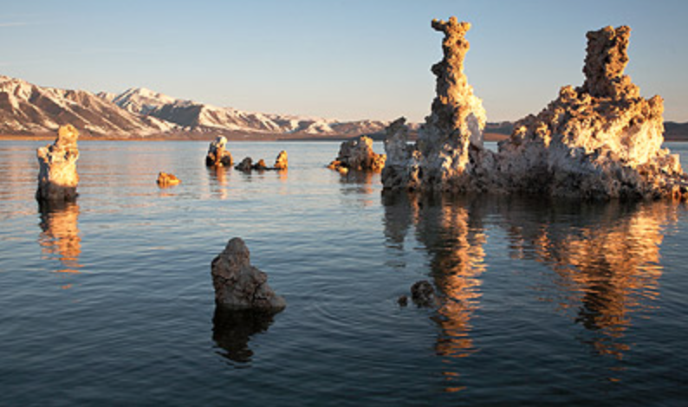
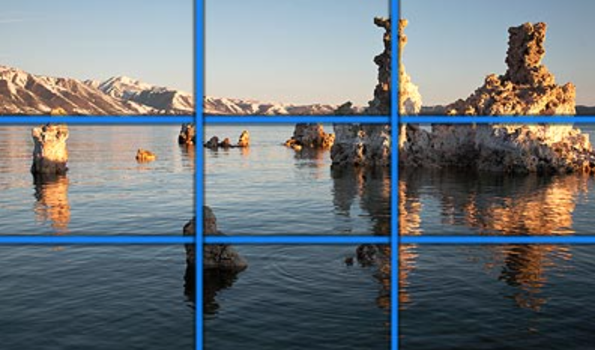

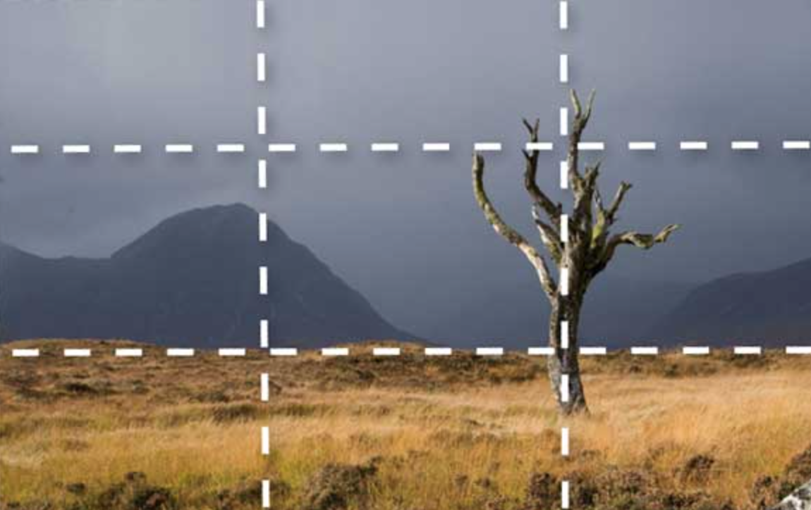
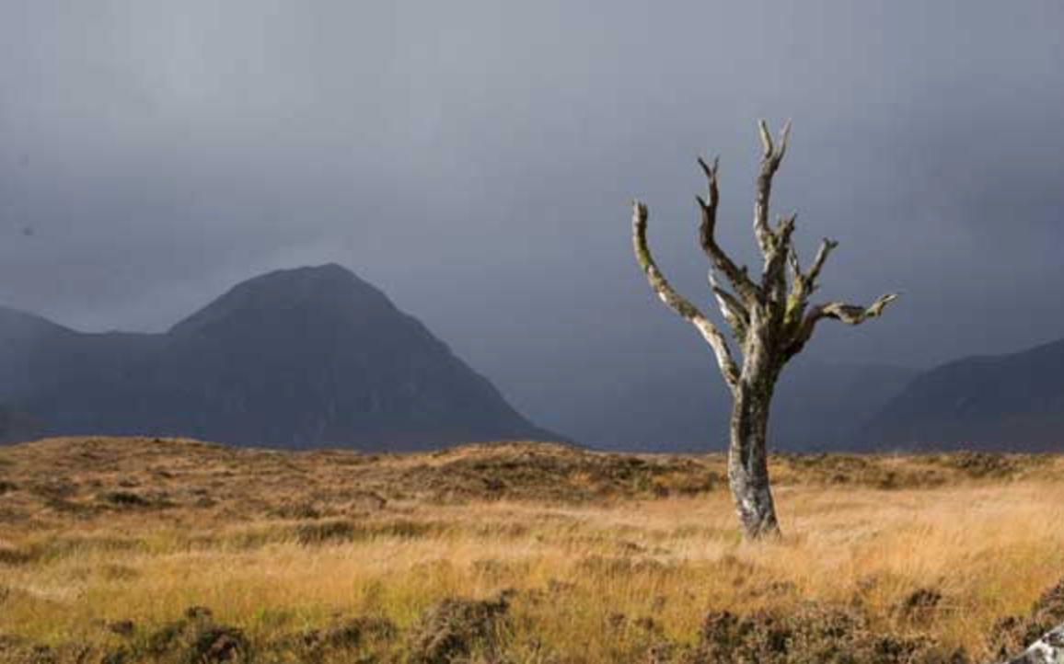

Viewpoint
The angle you take your photograph will have a big impact on your images. Most people stand and photograph from ‘head height’. Try crouching down to take photographs, or take it from a higher angle. Zoom in or out to fill the frame to make the shot more interesting. Take note of the background and consider how the angle you take your photograph from affects it. You should try and avoid or cut out busy and distracting backgrounds.

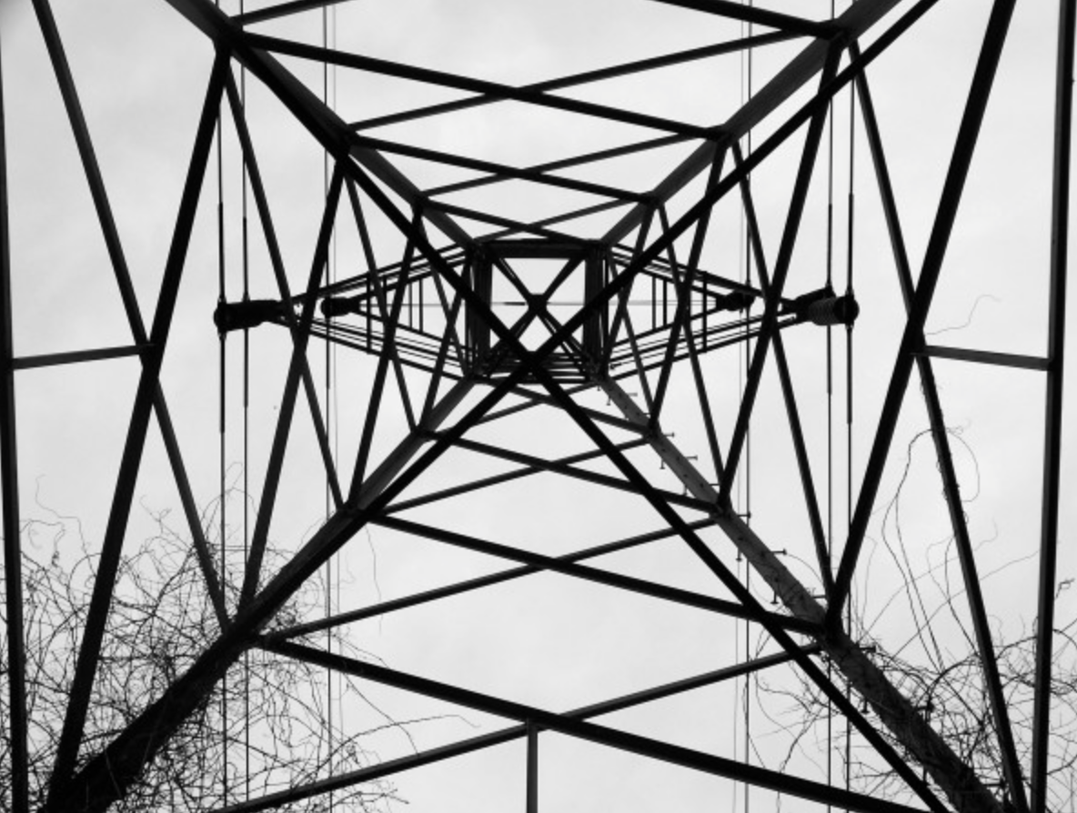
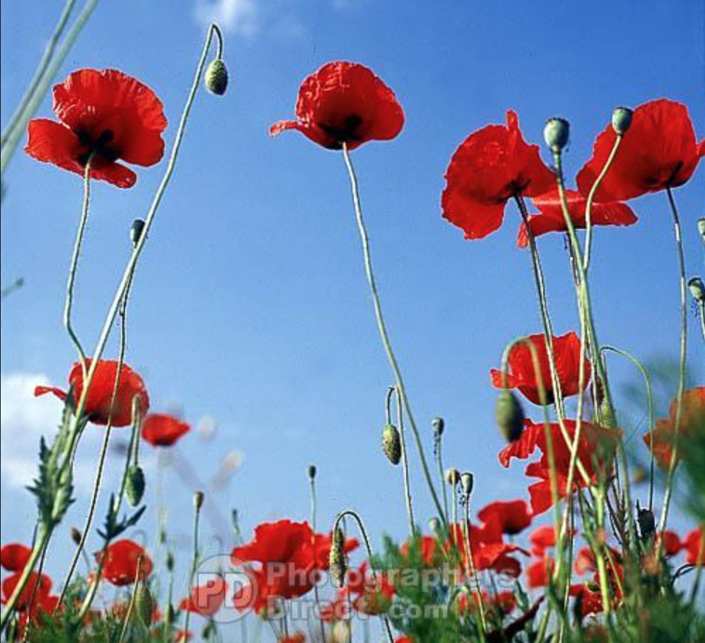

Camera Settings
- MODE: Set on P mode. This will stop the flash firing and giving you distracting shadows and reflections. It will also select the correct shutter speed and aperture for you.
- ISO: Set this to 400 or 800. This will increase how sensitive the camera is to light, enabling you to take photos in low light. Increase it, as it gets darker to avoid camera shake.
- WHITE BALANCE: This will appear on the camera as WB. To avoid a colour cast, set to auto or select the correct light source, fluorescent, daylight etc.
- Zoom: Try zooming out and moving really close to your subject to create slightly distorted images. Alternatively, you can position yourself a bit further back and zoom in to get extremely close up or a ‘macro’ effect.

